**EXPERIMENT-1**

**AIM:** Create a program that prompts the user for their name and age and prints a personalised message for the user.

**SOURCE CODE:**

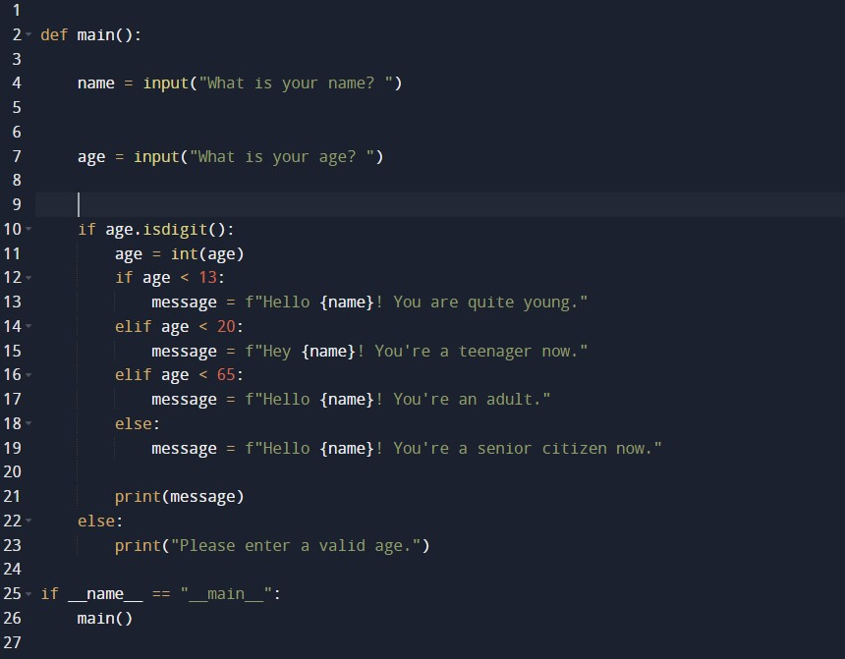

**OUTPUT:**

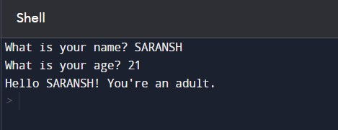

**EXPERIMENT-2**

**AIM:** Create a program that prompts the user for their name and age and tells them if they can vote for next elections.

**SOURCE CODE:**

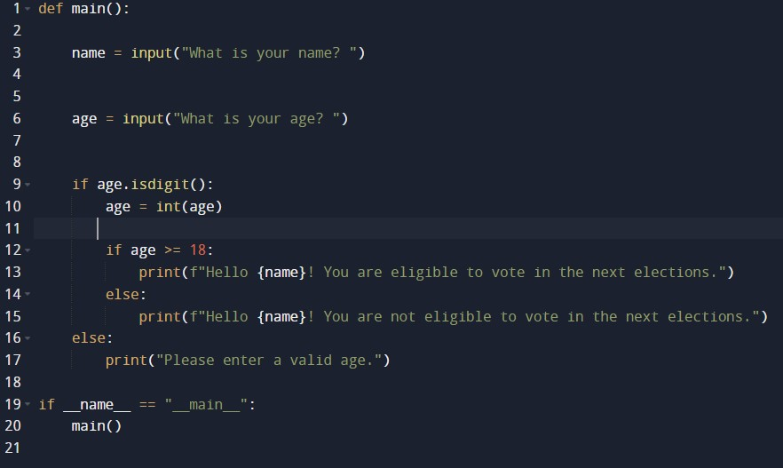

**OUTPUT:**

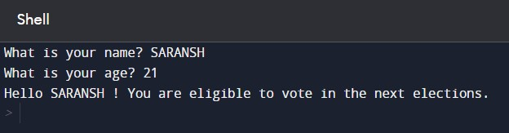

**EXPERIMENT-3**

**AIM:** Create a program that calculates the factorial of a number, given by the user. using the concepts of loops.

**SOURCE CODE:**

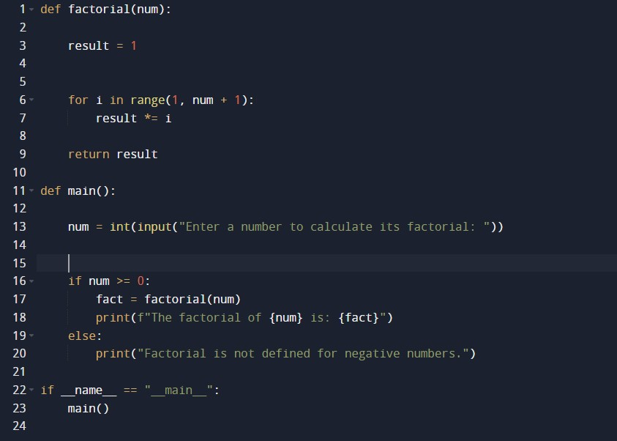

**OUTPUT:**

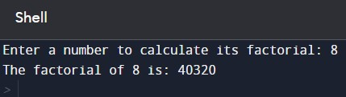

**EXPERIMENT-4**

**AIM:** Create a program that prompts the user for a list of numbers and then sorts them in an ascending order.

**SOURCE CODE:**

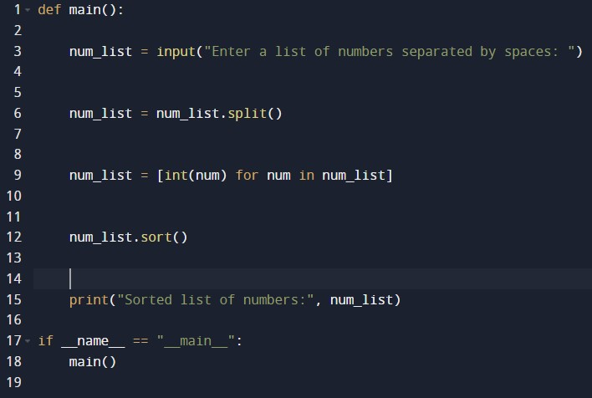

**OUTPUT:**

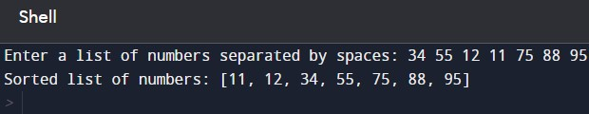

**EXPERIMENT-5**

**AIM:** Create a program that prompts the user for a string and then prints the string in the reverse order.

**SOURCE CODE:**

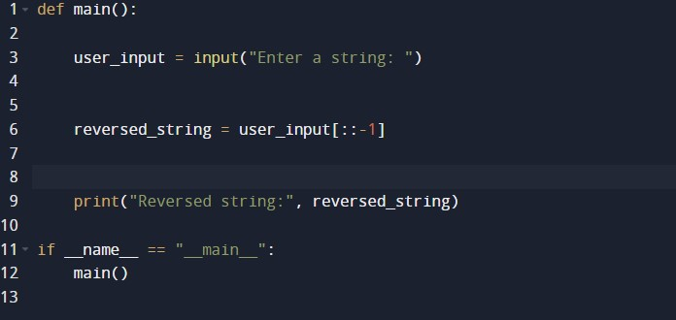

**OUTPUT:**

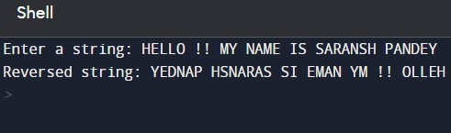

**EXPERIMENT-6**

**AIM:** Create a program that defines a function which calculates the area of a circle based on the radius entered by the user.

**SOURCE CODE:**

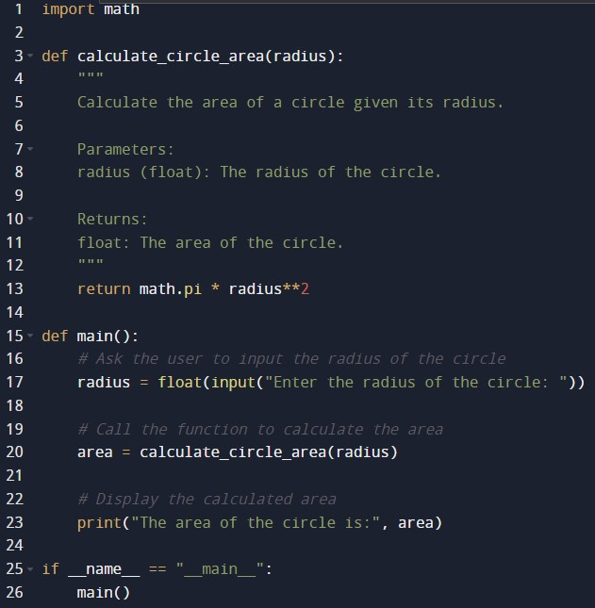

**OUTPUT:**

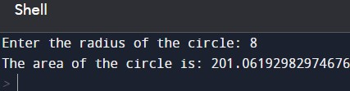

**EXPERIMENT-7**

**AIM:** Create a program that defines a class to represent a car and then creates an object for that class with specific attributes.

**SOURCE CODE:**

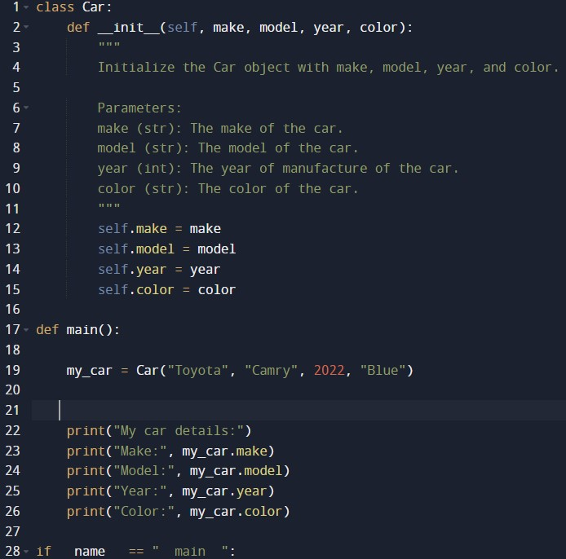

**OUTPUT:**

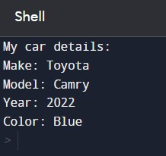

**EXPERIMENT-8**

**AIM:** Create a program that reads data from a file and writes it in another file in a different format.

**SOURCE CODE:**